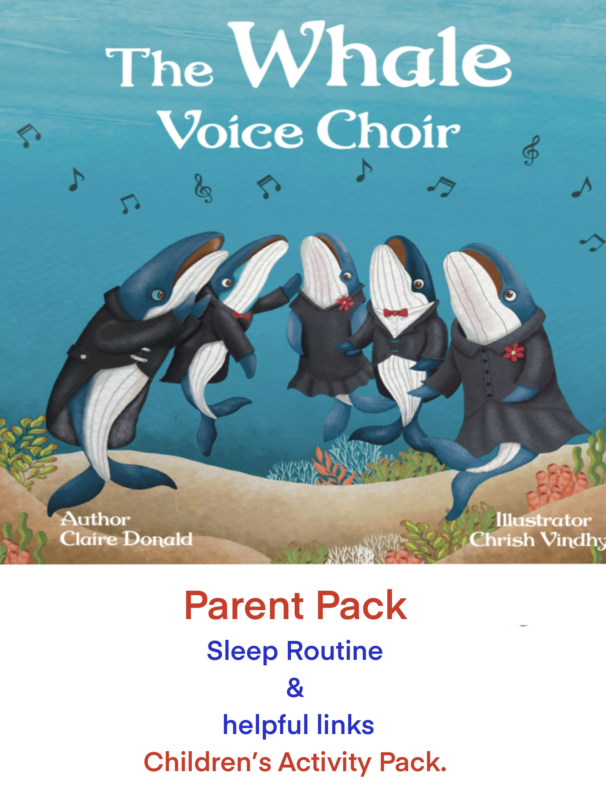

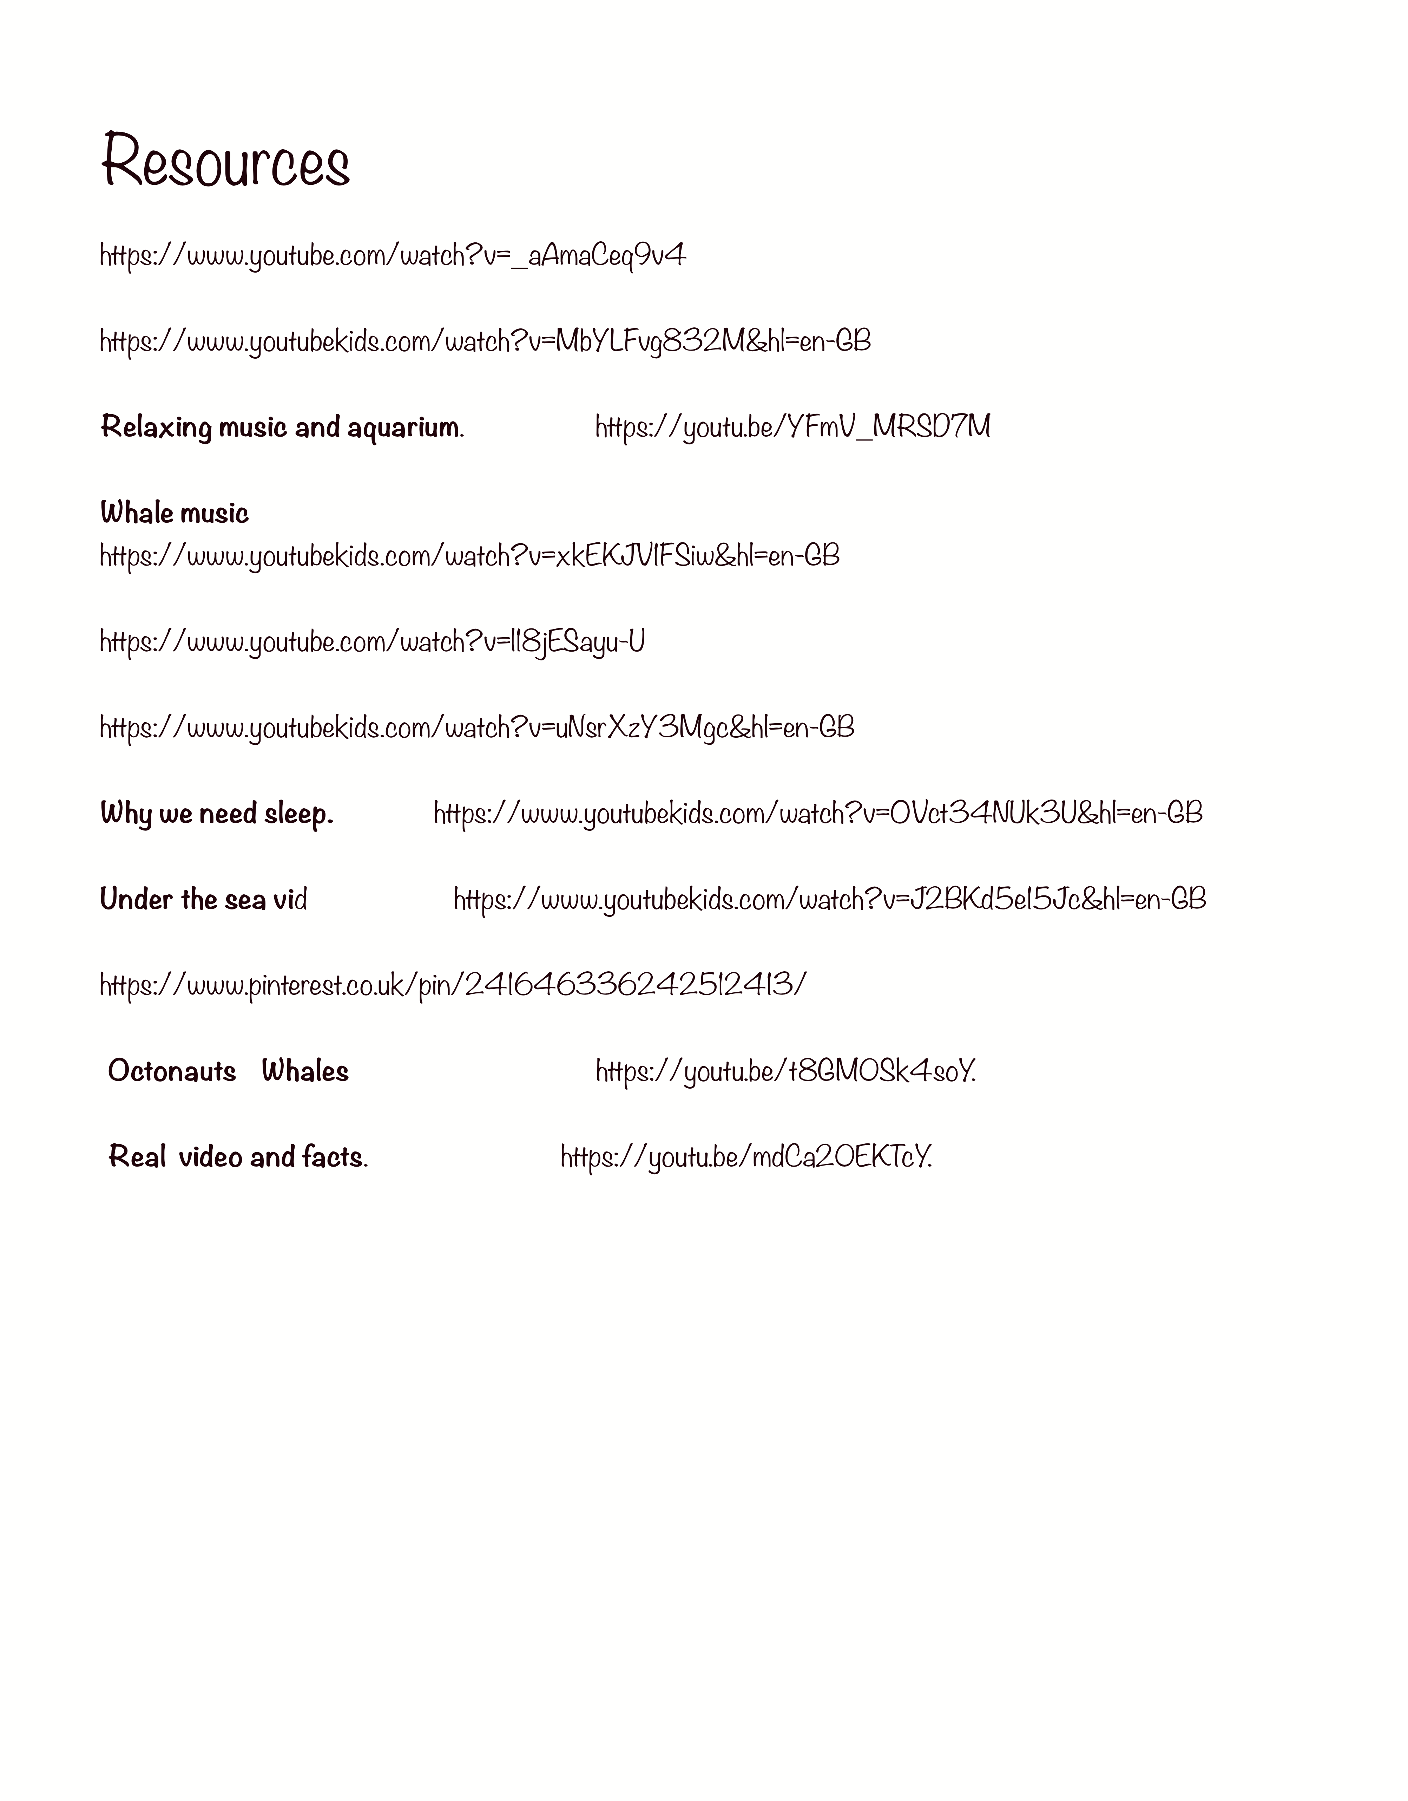
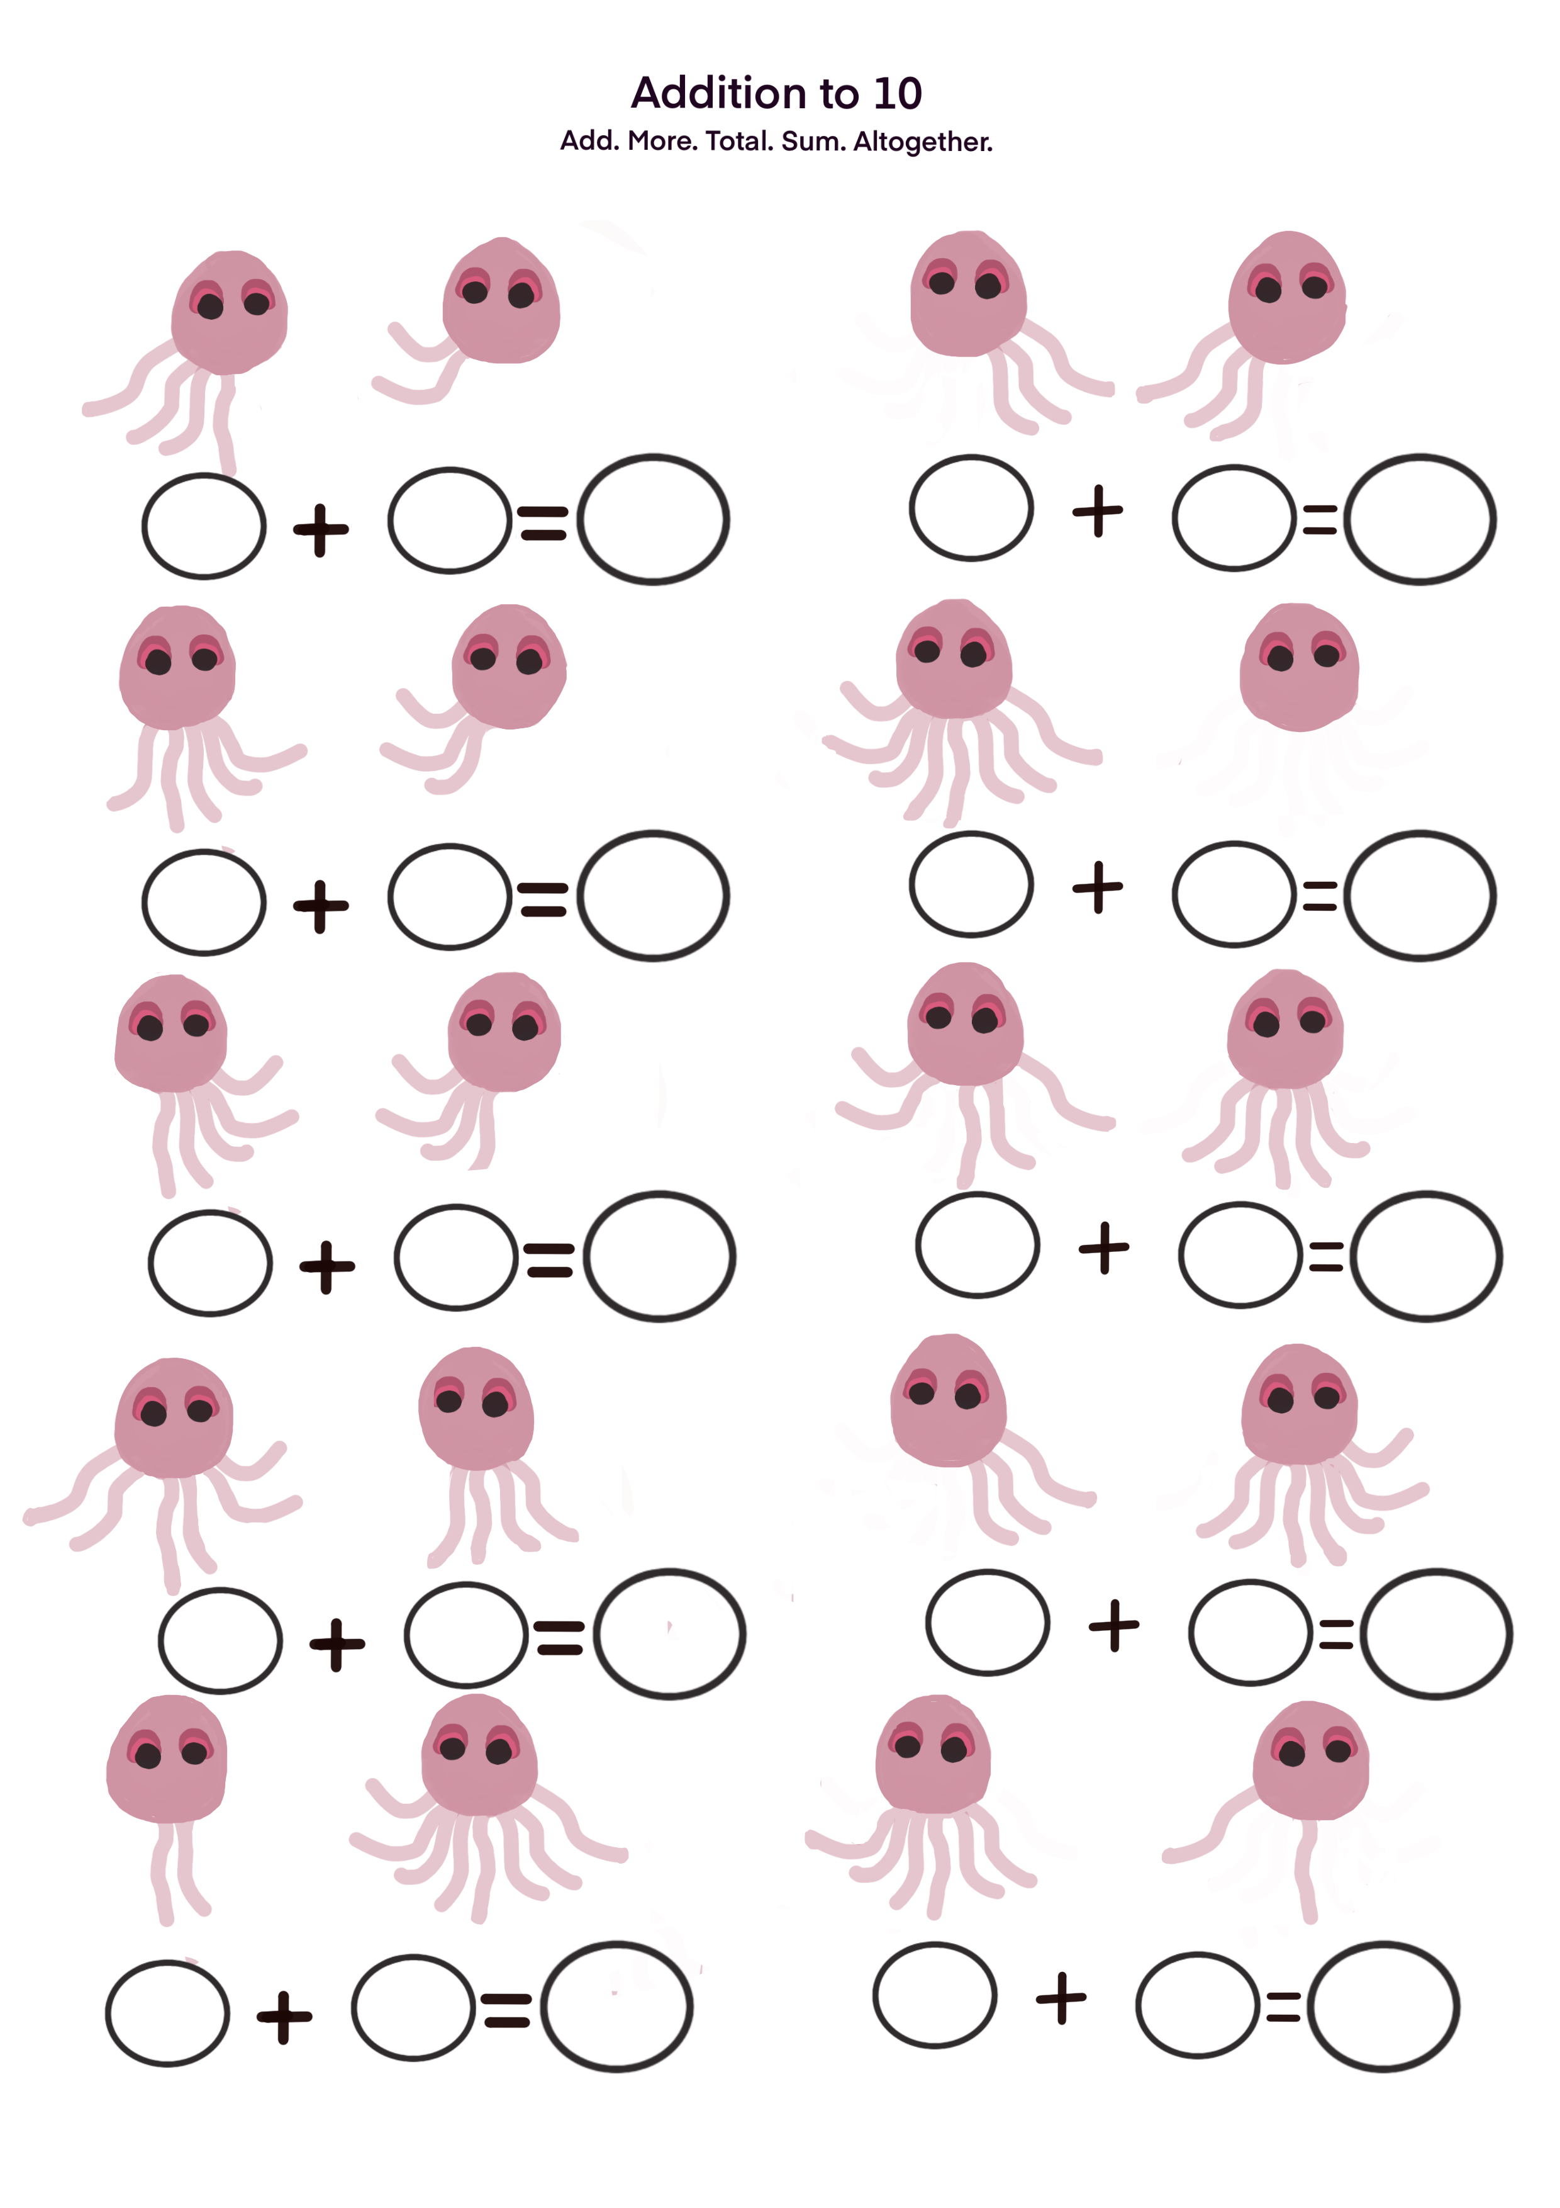
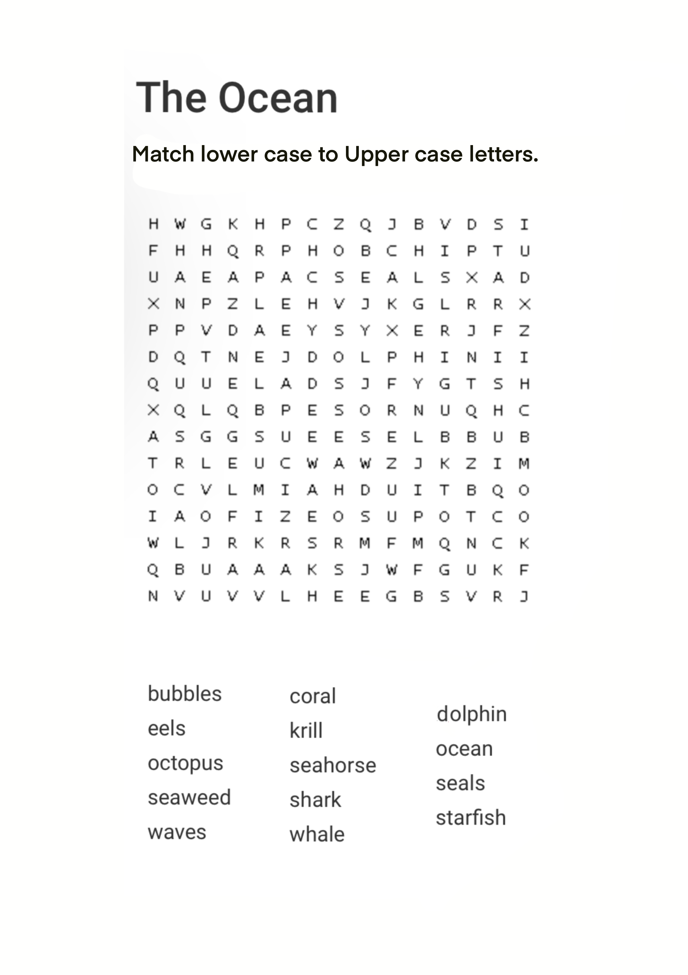

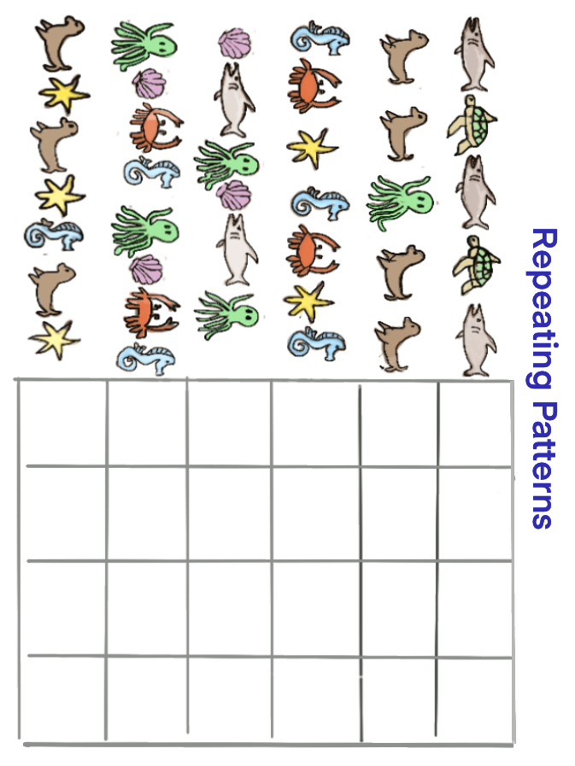

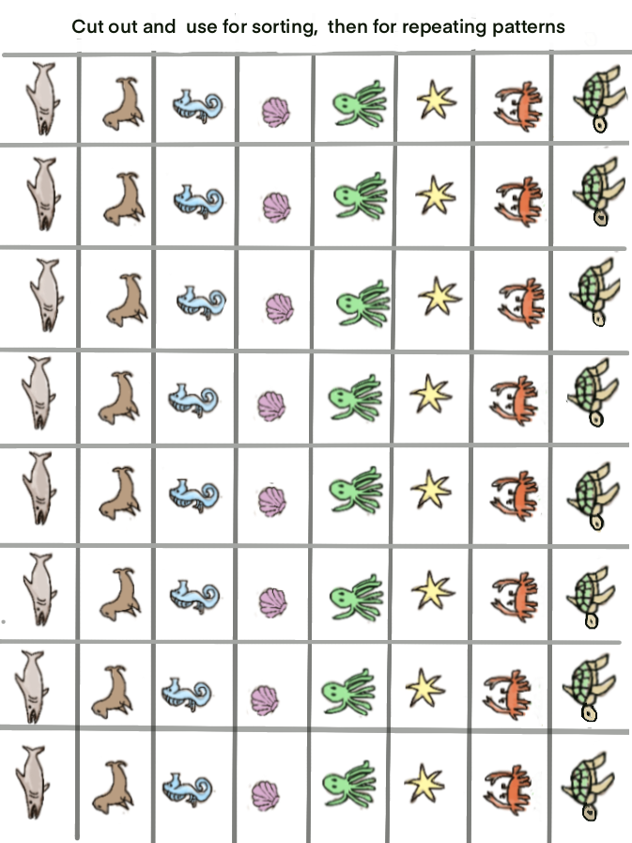

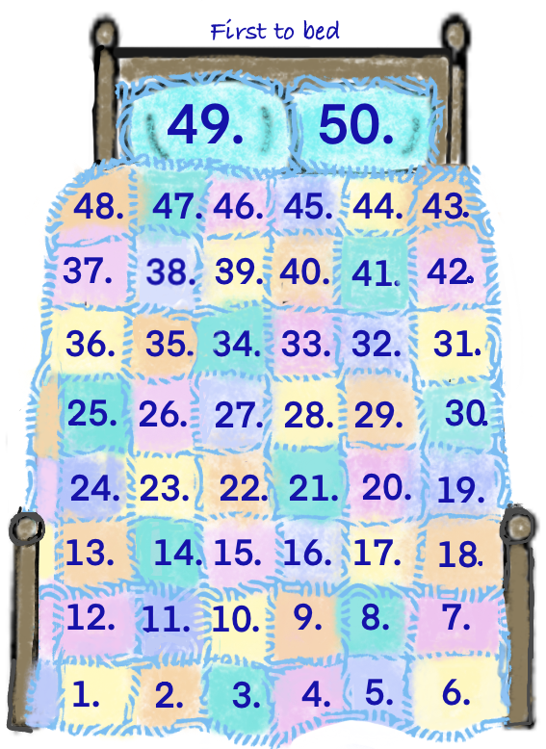
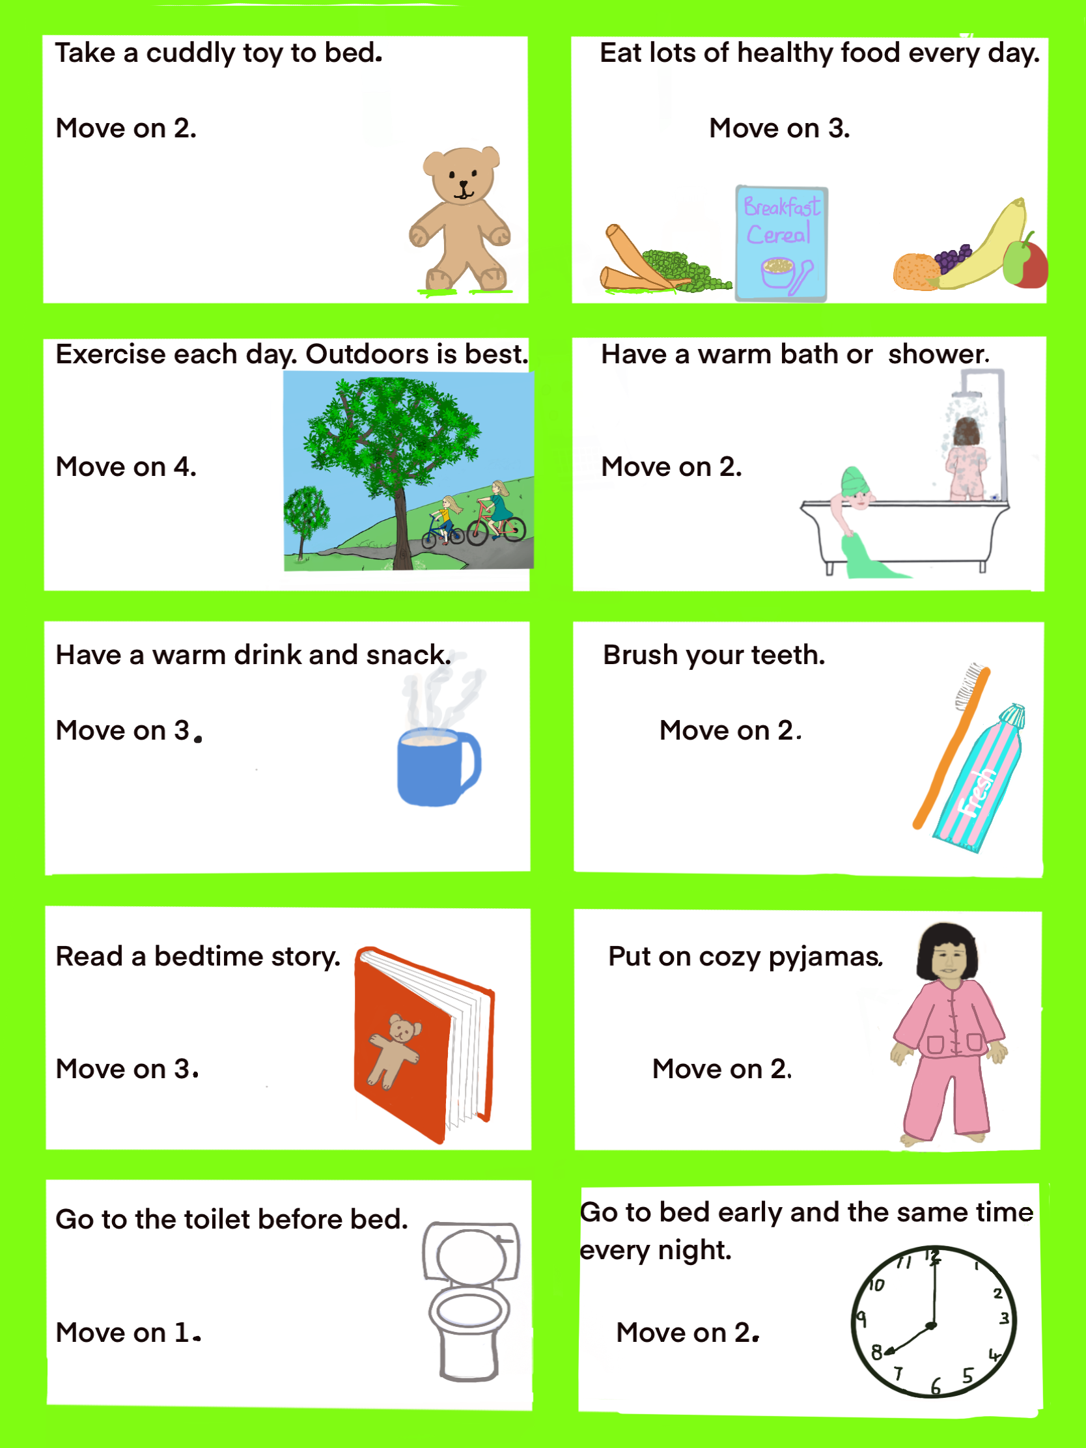
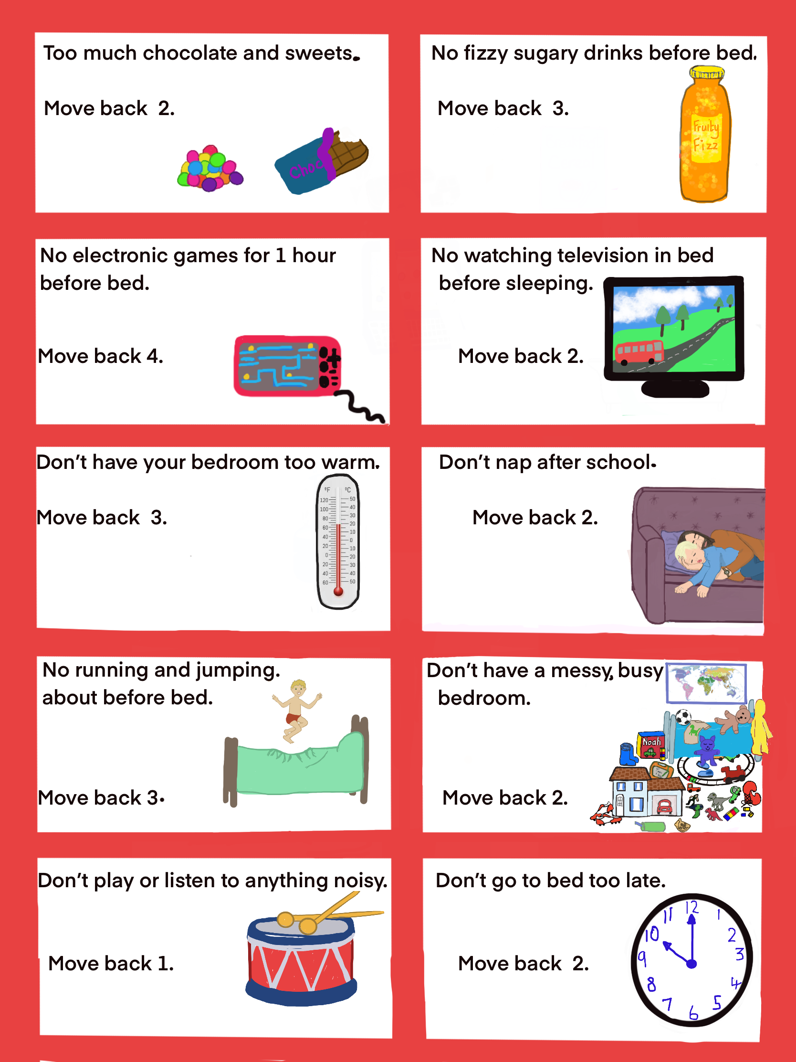
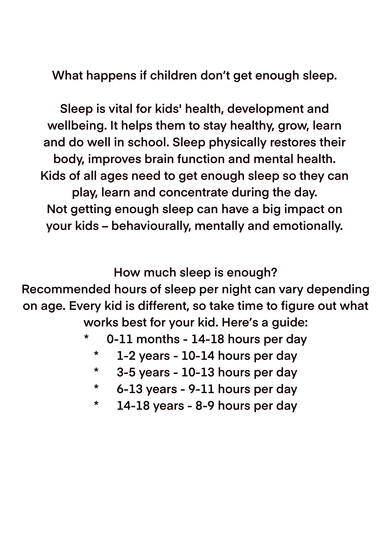
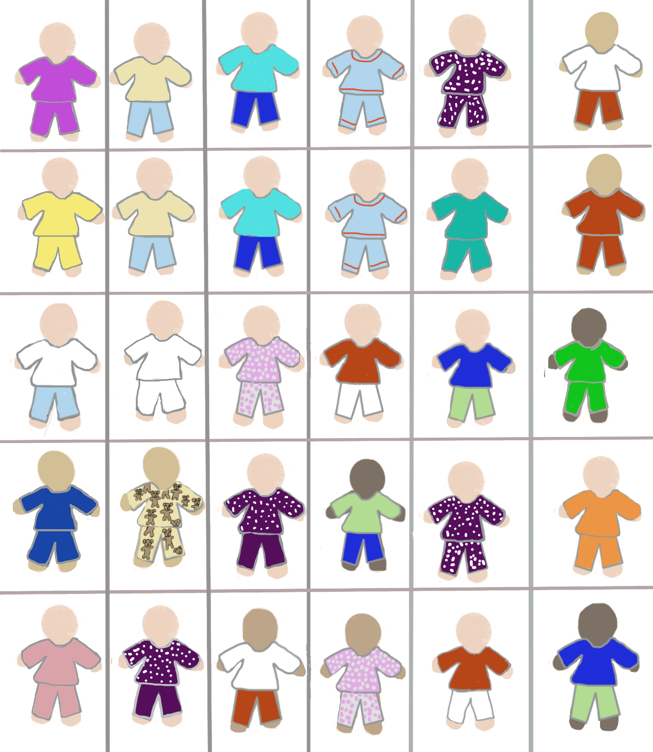
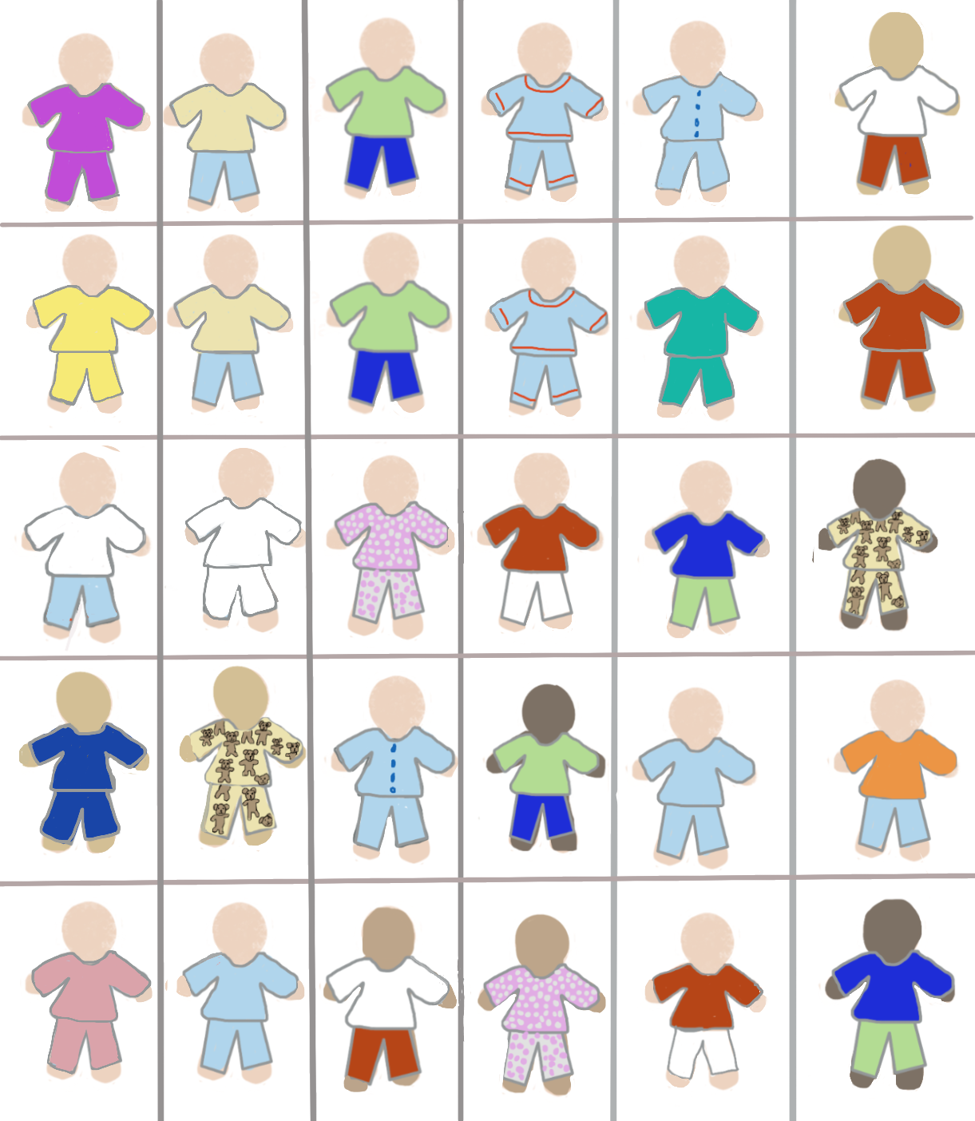

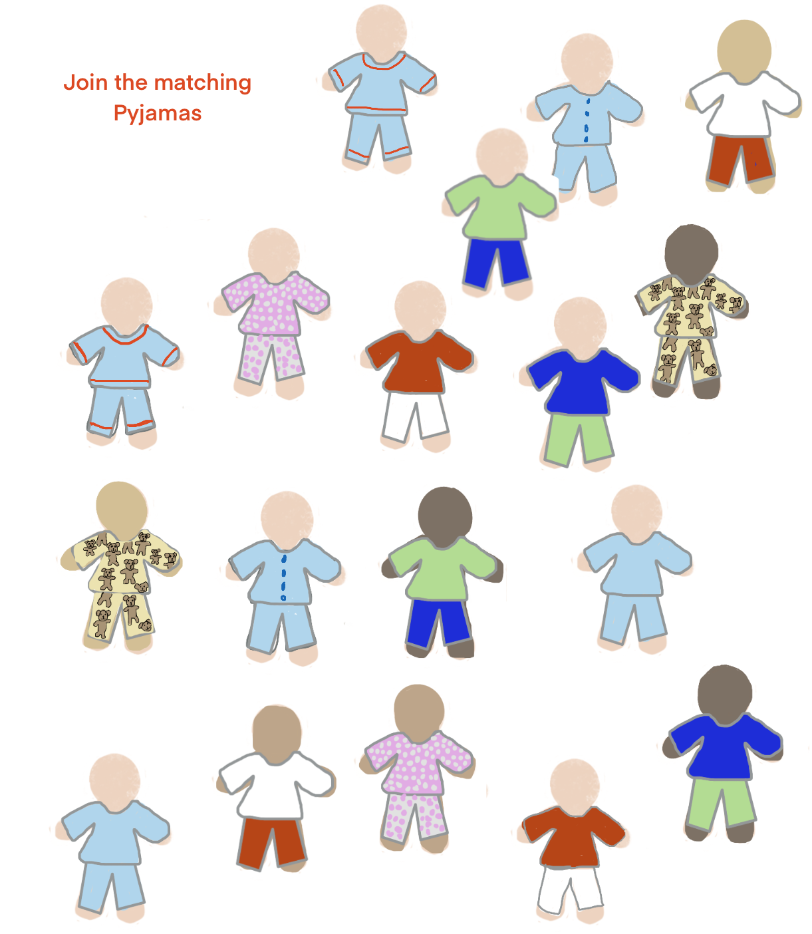

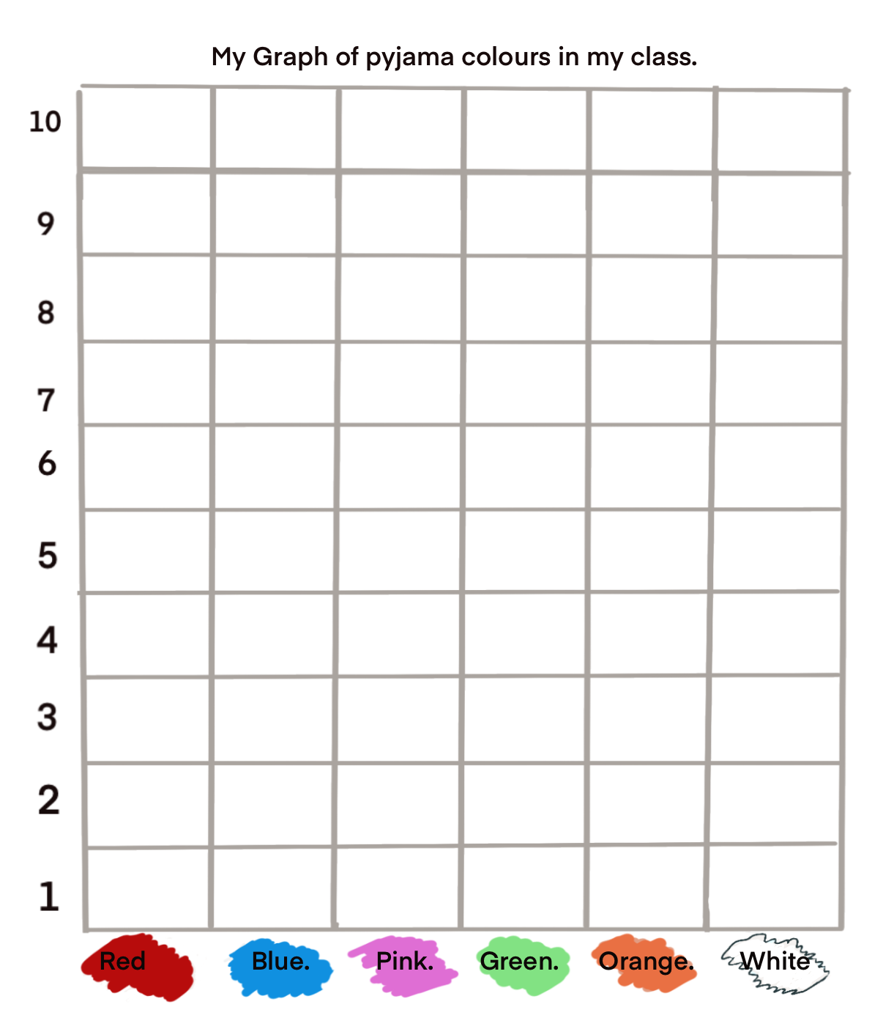Q

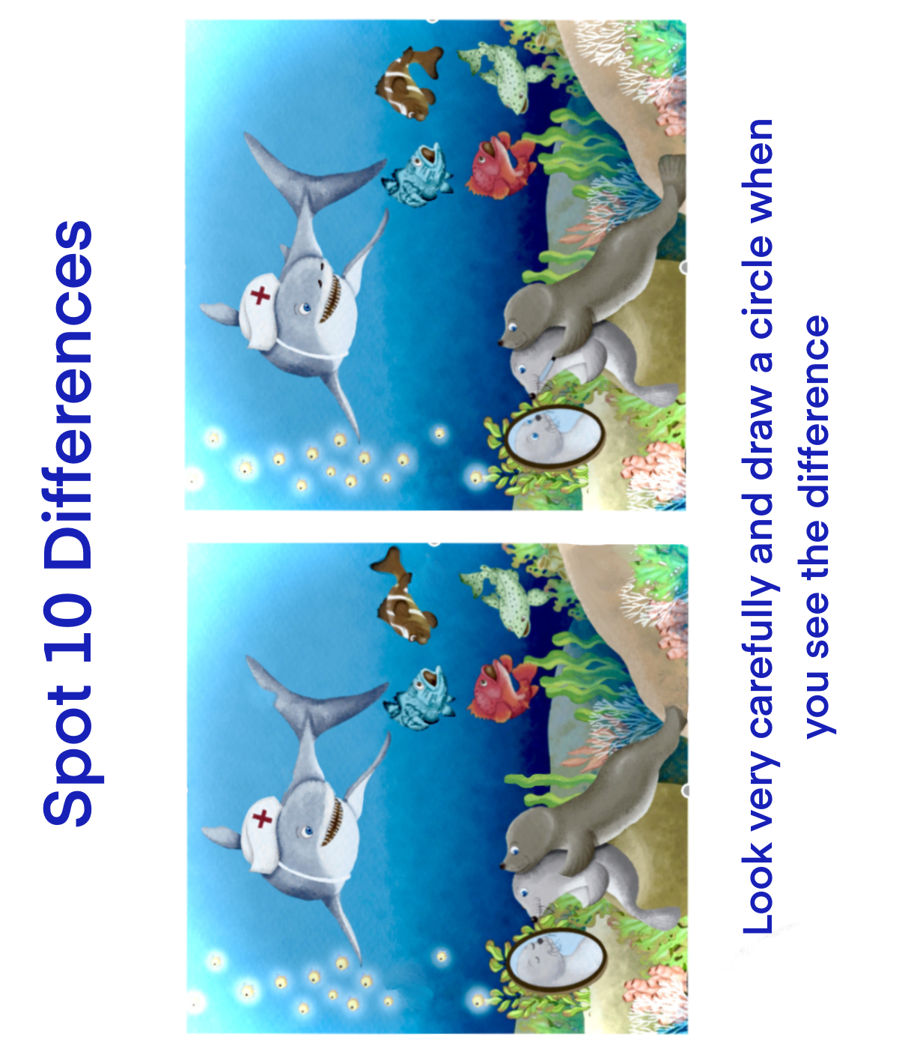

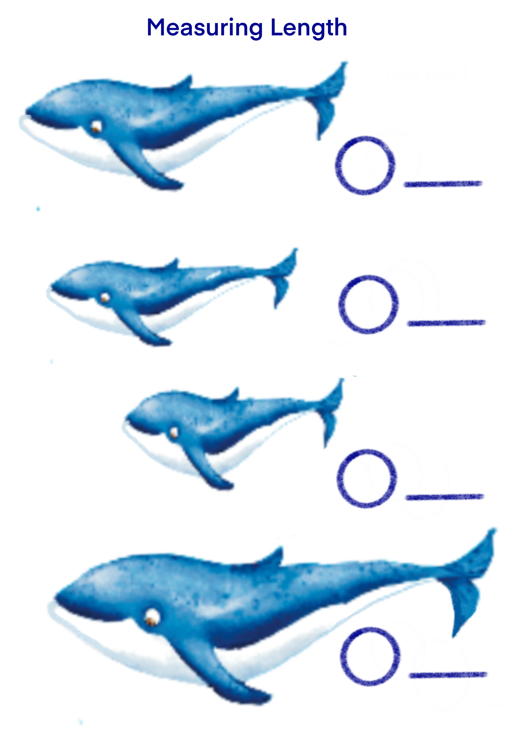

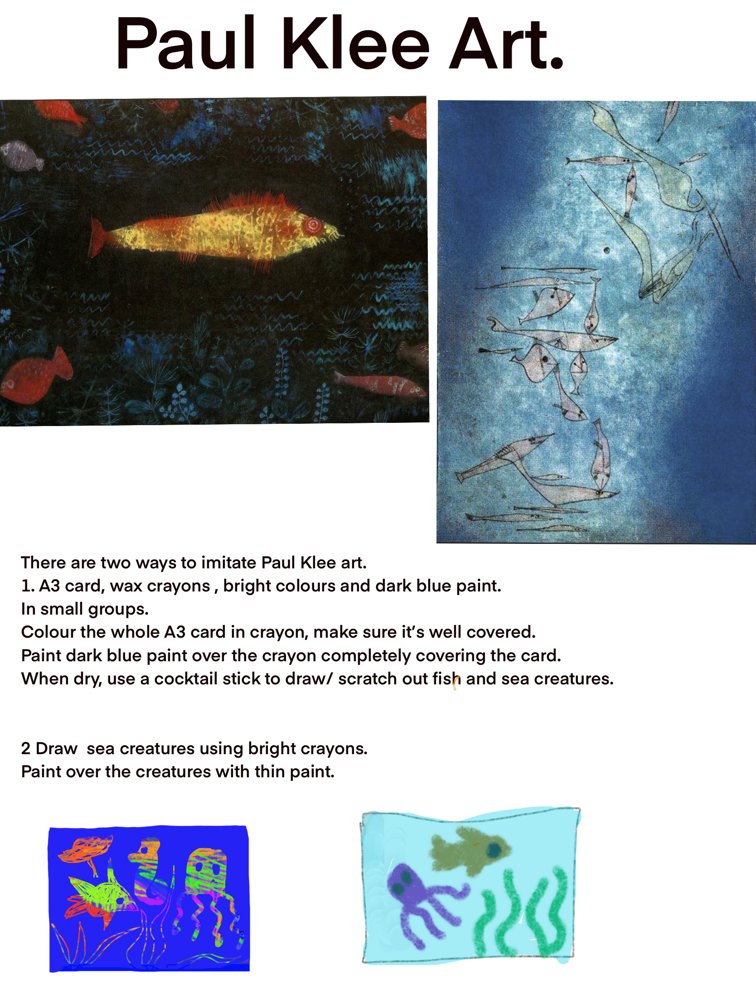

https://www.youtube.com/watch?v=uffMjgYhvlM



https://www.youtube.com/watch?v=9pRhgZ8Jffs
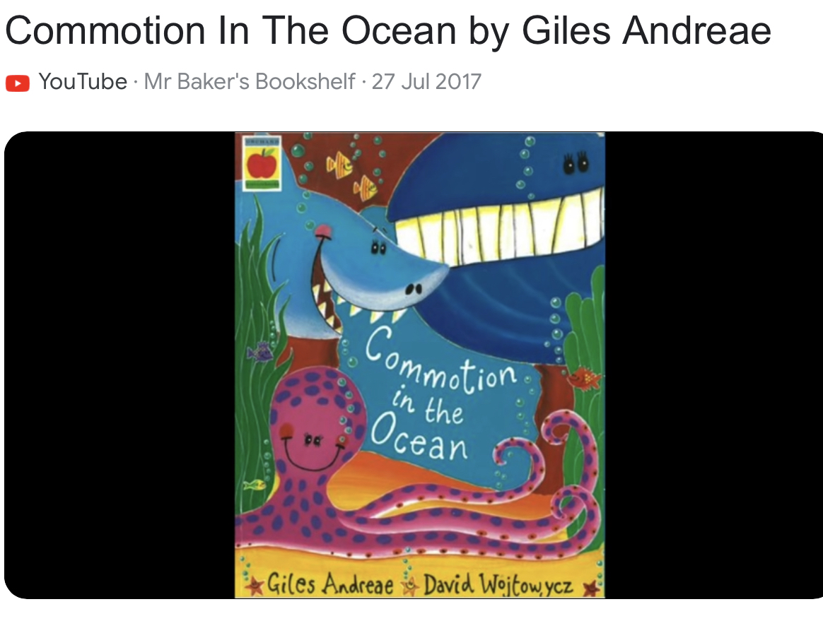
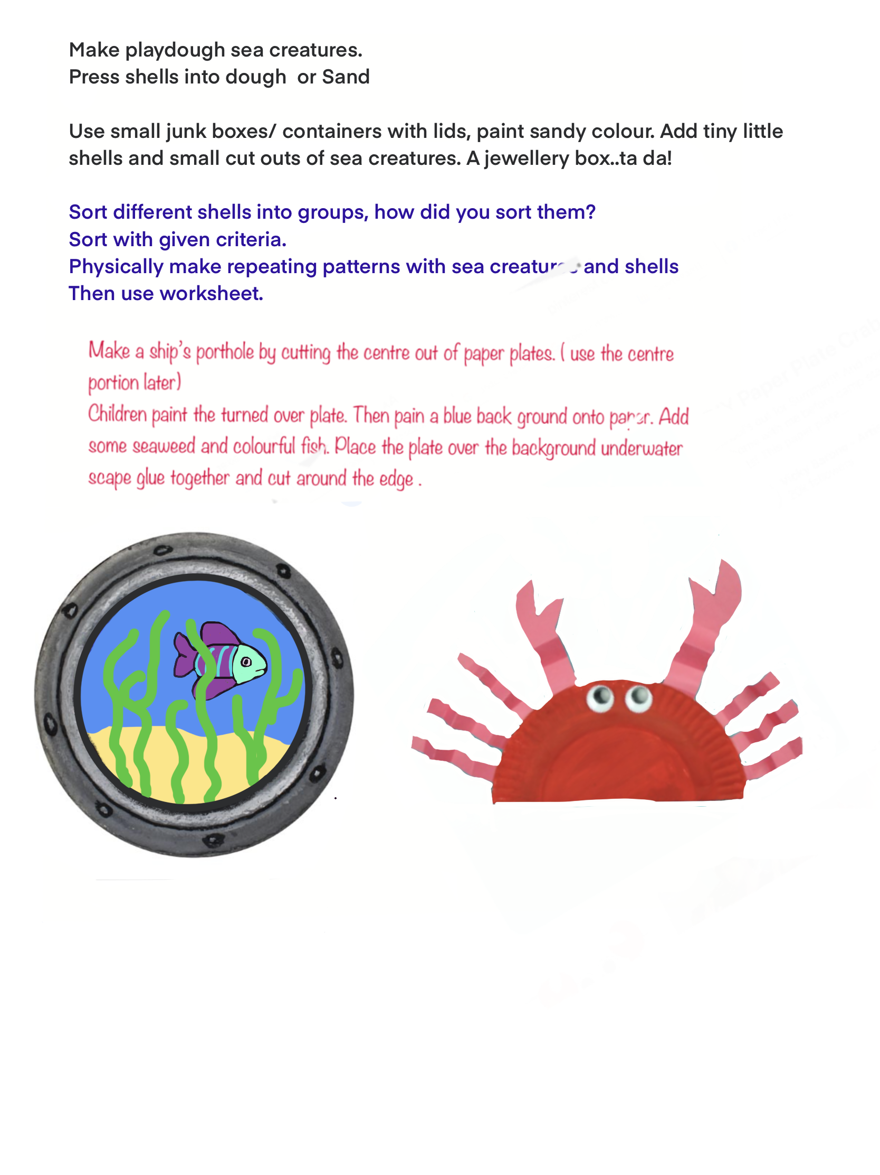

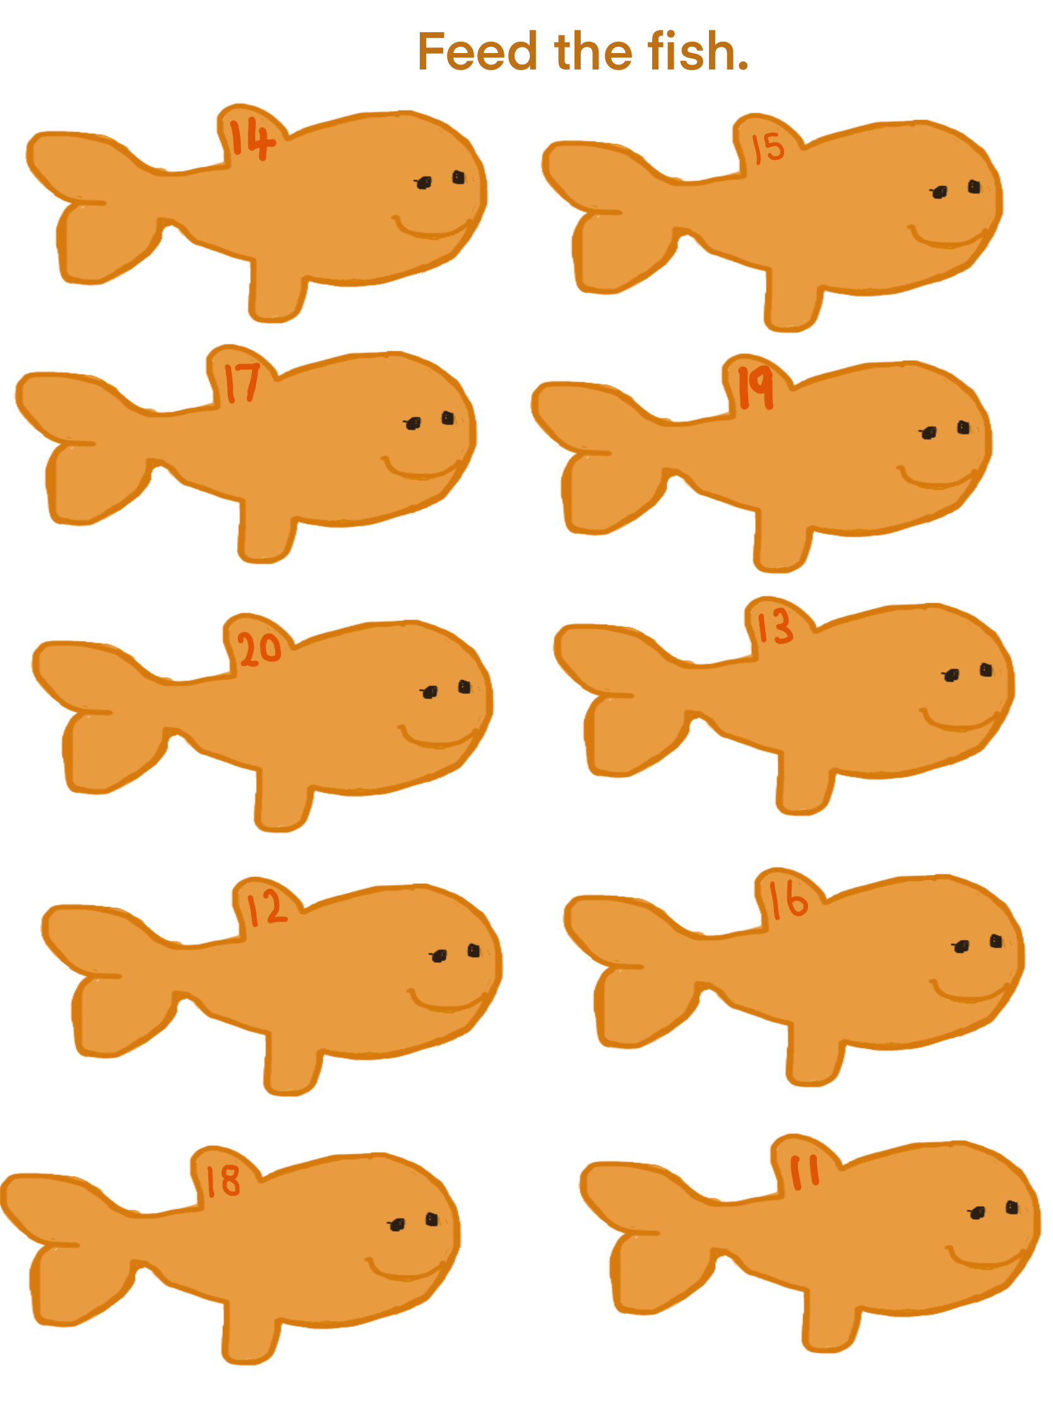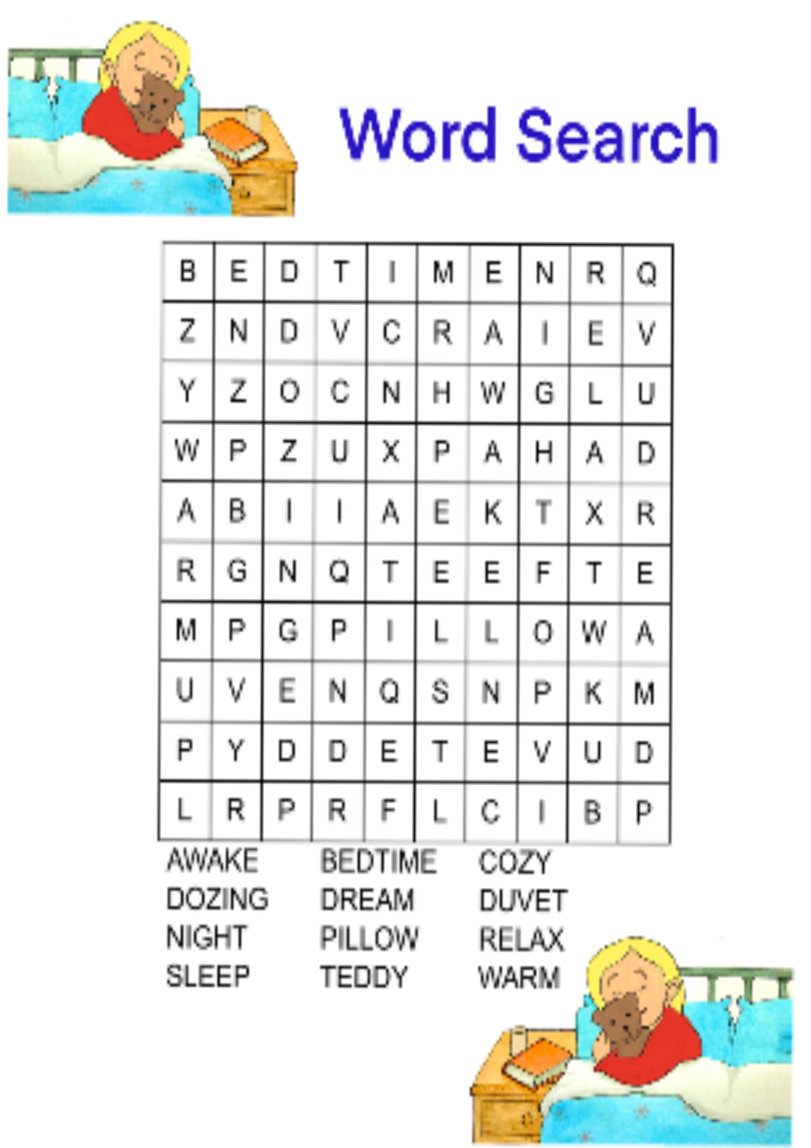

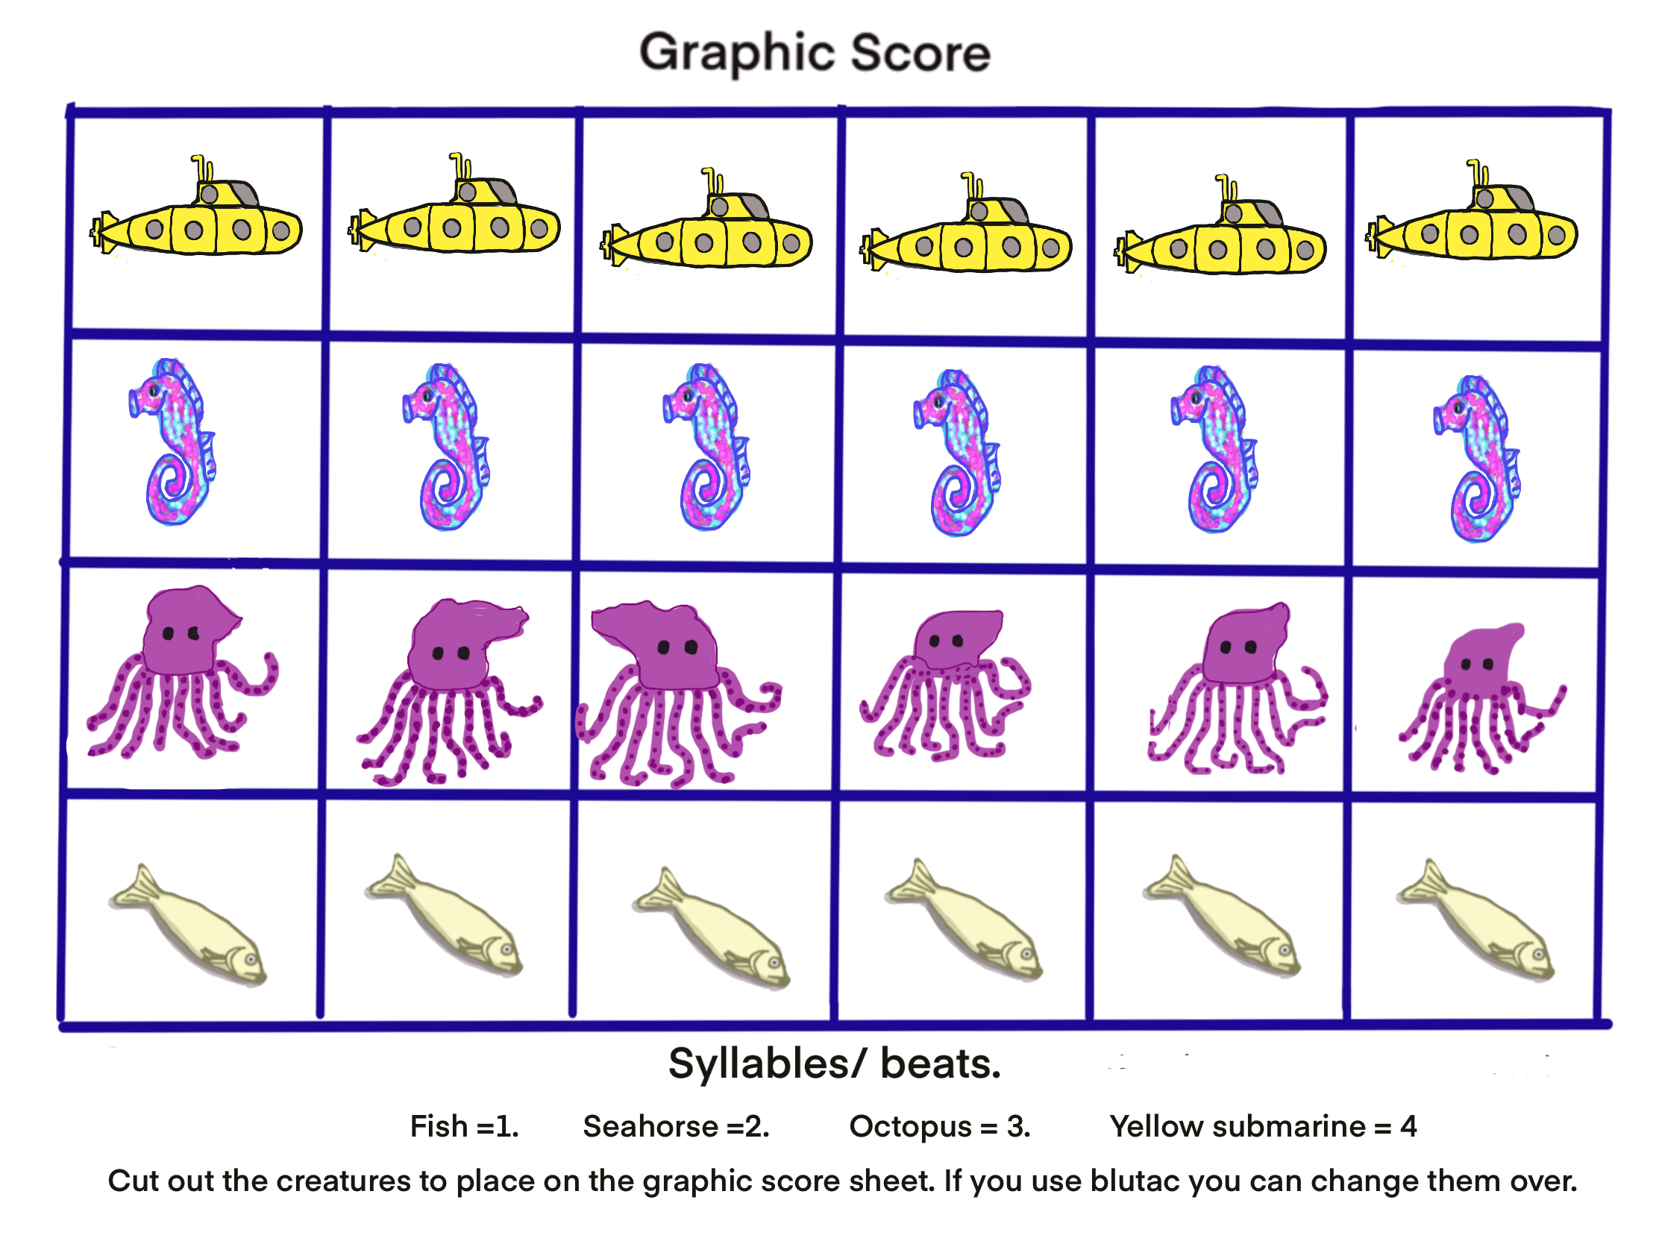

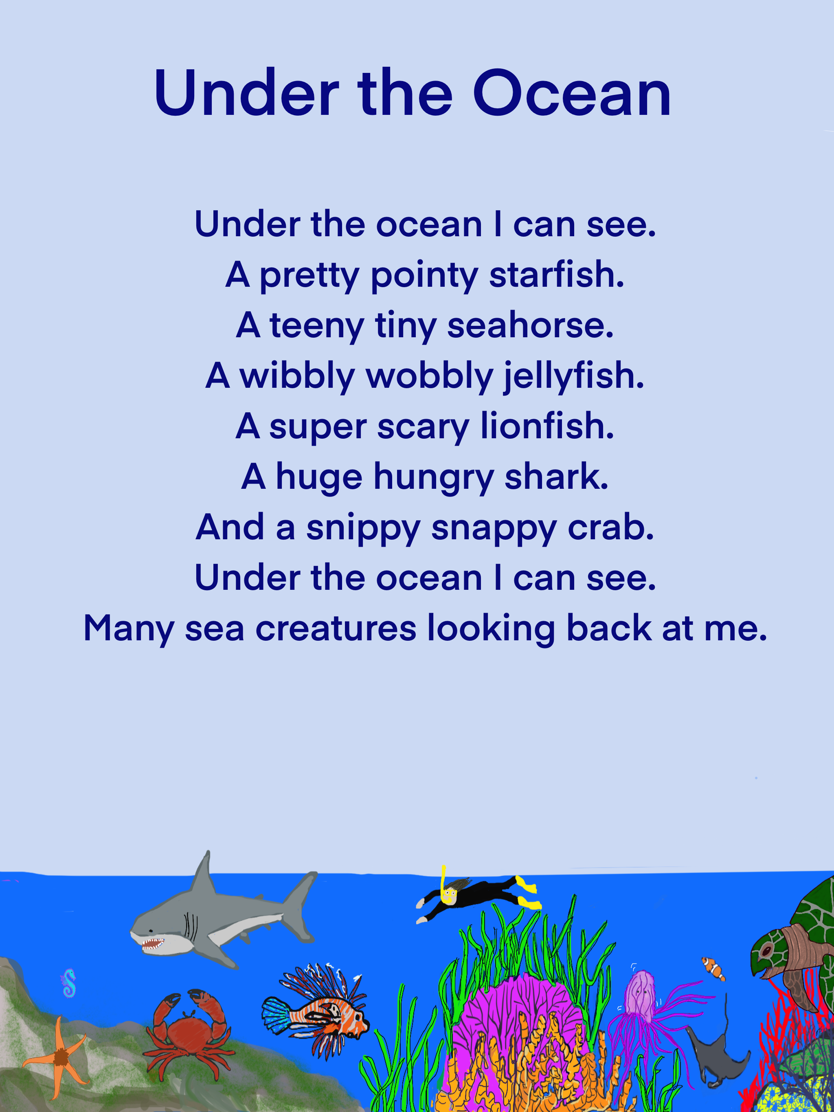



The Octopus

Octopuses are very smart.
Contortion is their special art.
They are all masters of disguise.
Shapeshifting right before your eyes.
Around their prey long tentacles tangle.
Constricting the creature to quickly strangle.
And when the prey at last succumbs …
They eat their dinner with their bums!

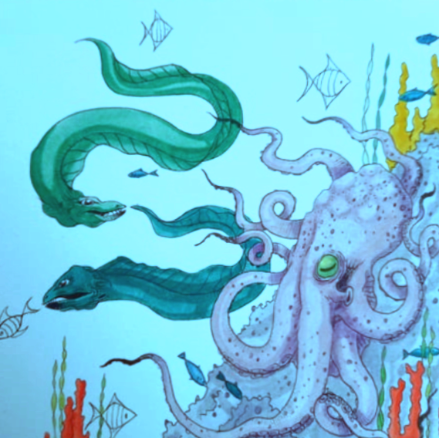

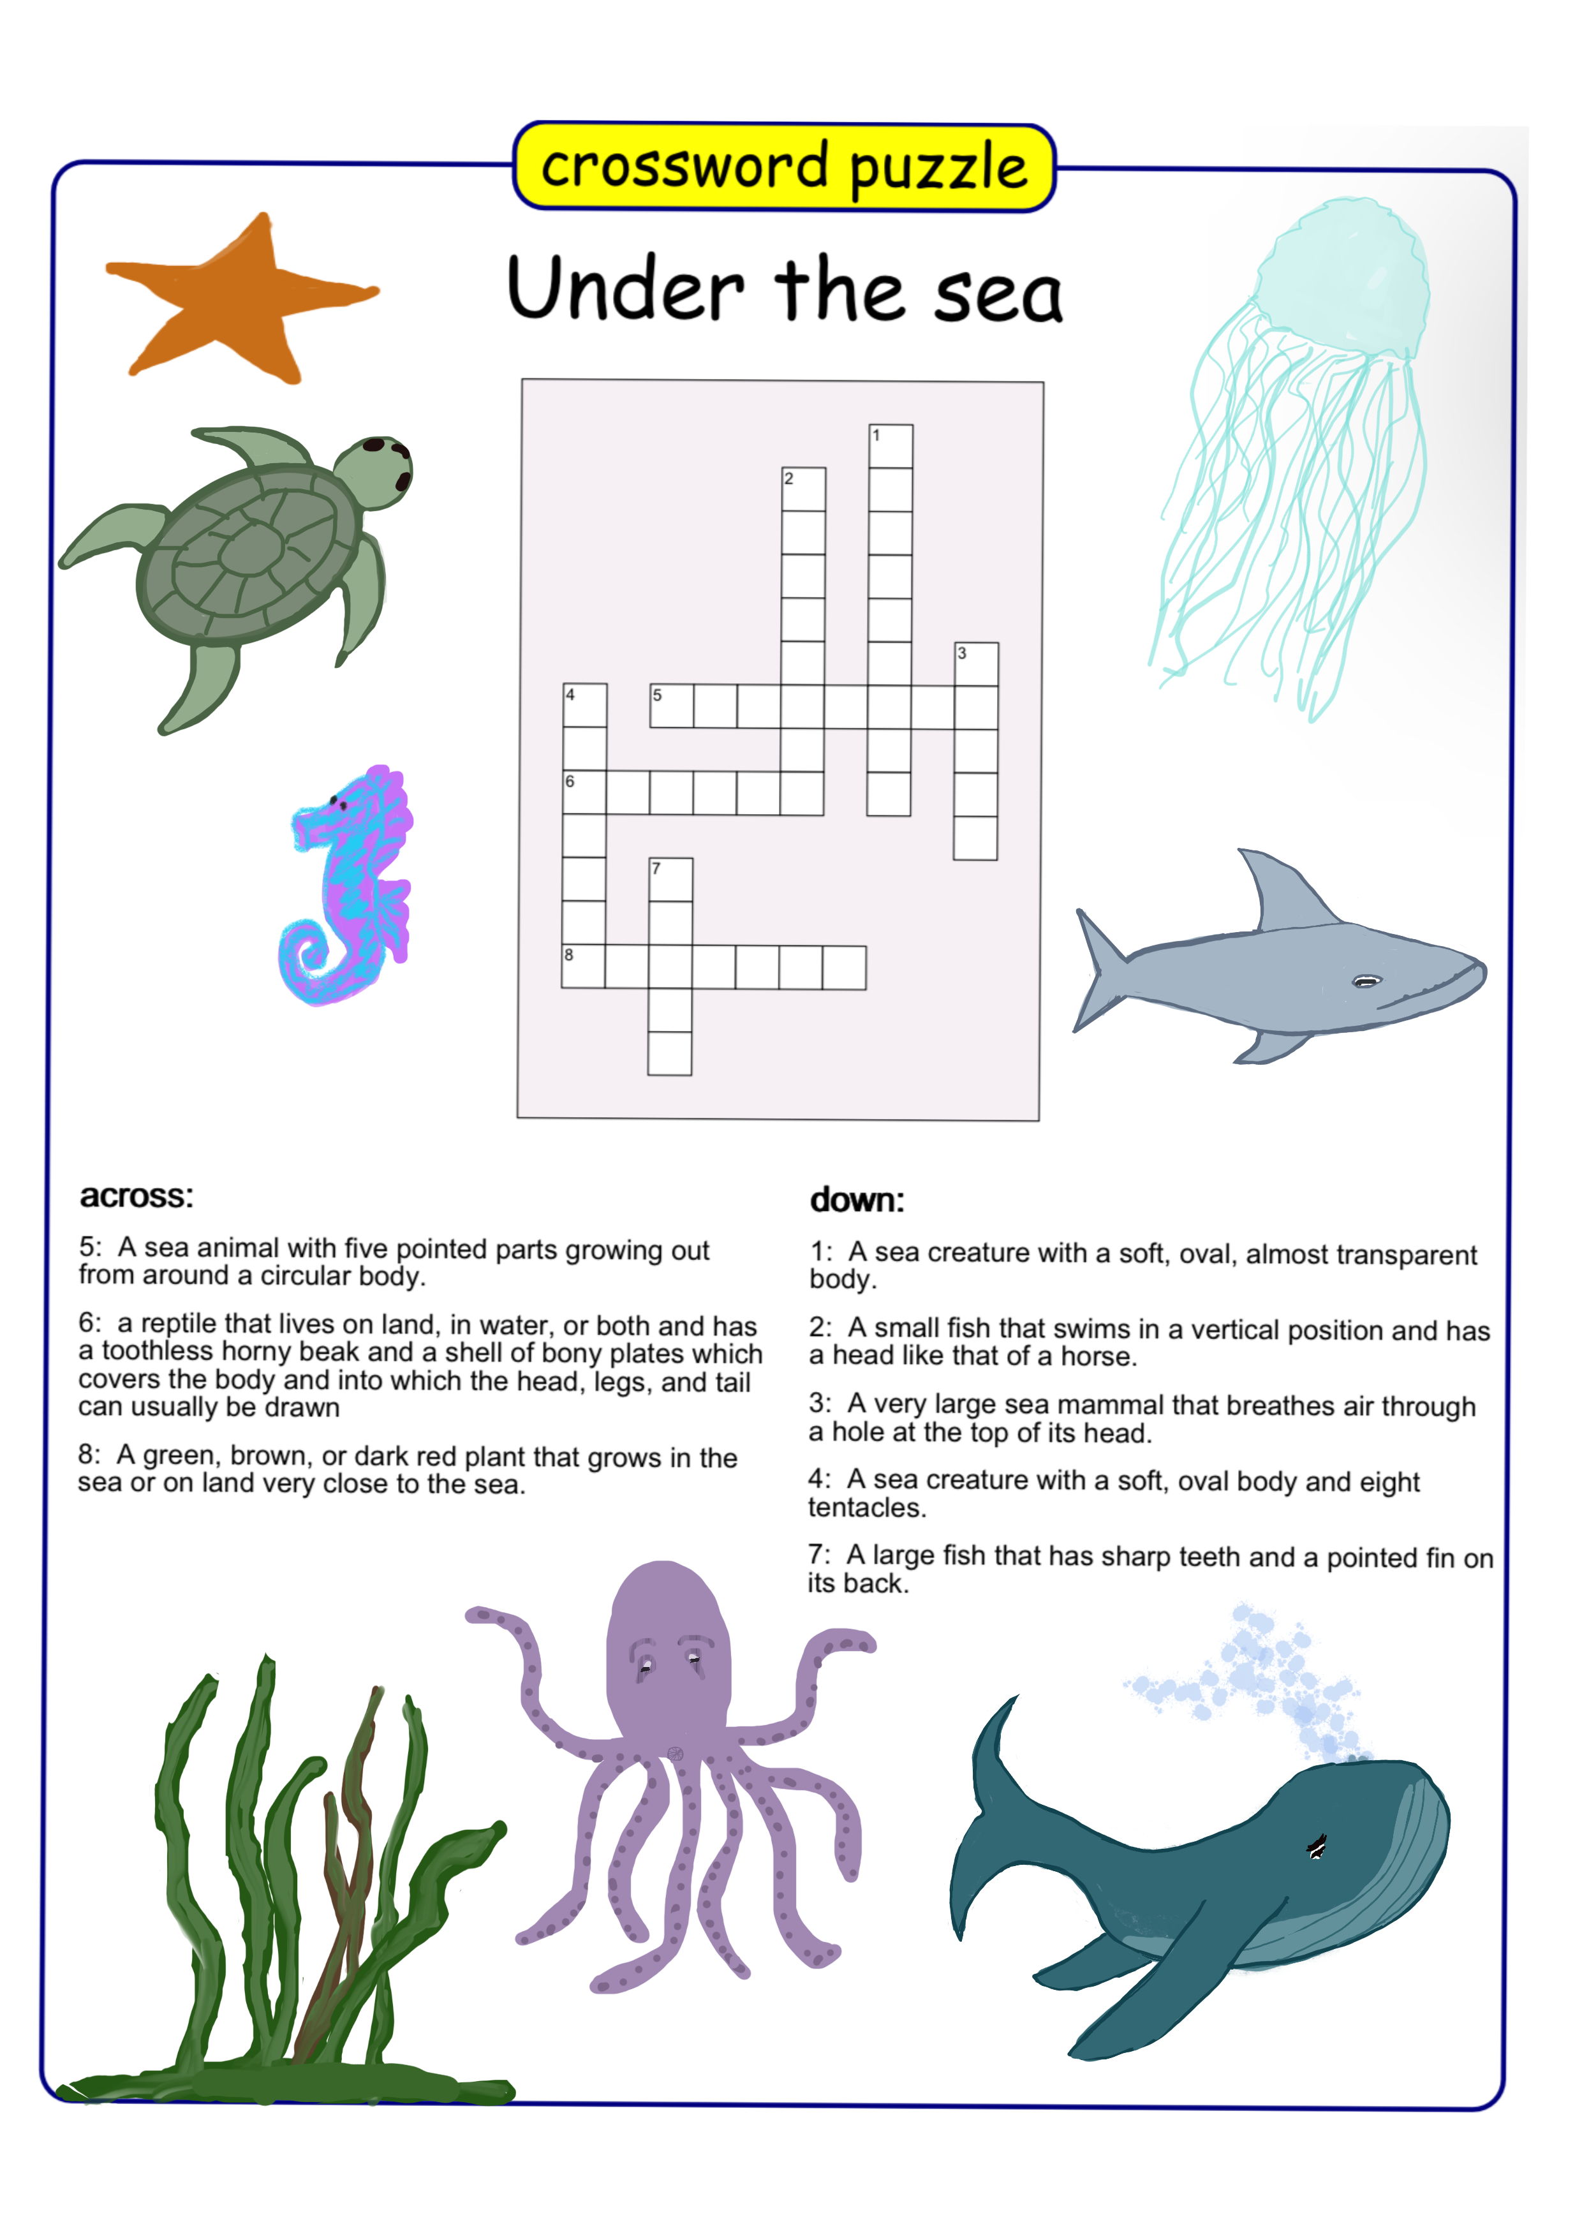
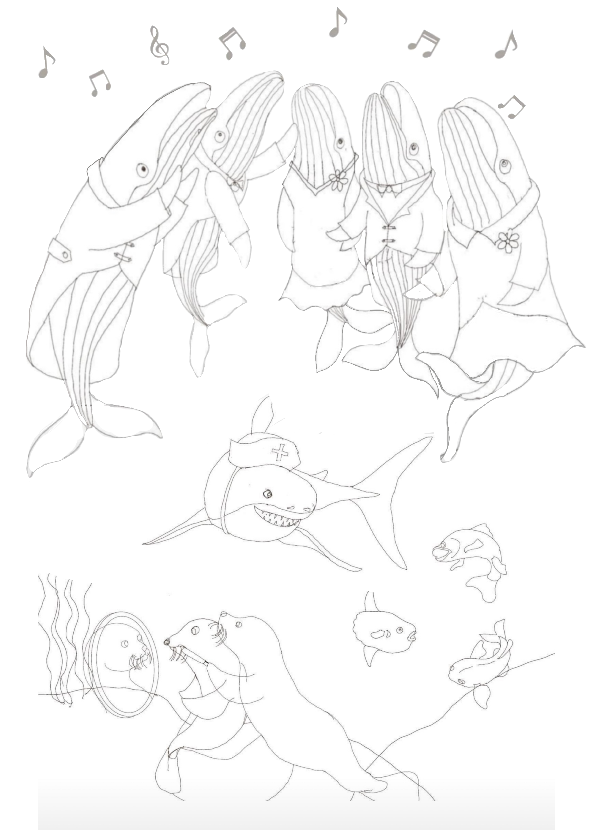
Before starting the sleep routine

Make sure you have everything you need before starting the routine.
Soft whale, lavender heart, reward chart, and reward ready, light or projector. (Some children need complete darkness.) whale music, Whale pyjamas.

Make sure you will be at home every night at the same time for the 2 weeks. It needs to be planned to establish the routine.

A week before the start date

Pop the cuddly toy into your own Panama top every night while you sleep for a week.
The toy should now have picked up own special smell that the child will be familiar with.

Routine,

1. Make a game of tidying toys and clothes etc. away in the bedroom. Put boxes out to throw and catch toys and place in the proper place. The bedroom shouldn’t be cluttered.
2. Warm bath/shower dress in special pyjamas. Dry hair.
3. Warm milk (or other drink) not too much. Small snack
4. Clean teeth.
5. Read or quietly, sing nursery rhymes with your child NOT in BED
6. Say, it’s time for our lovely sleep story, then it’s time for music while you shut your eyes and sleep. Here is your sticker ready for the morning, (reward chart).
7. I will check to see how well you are sleeping after I have got every thing ready for tomorrow.
8. Then go to bed
9. Read The Whale Voice Choir. Turn music on very quietly.

Any worries
Any dreams

